**USER GUIDE**

Here we minimize the login step that user can go directly to the main screen.

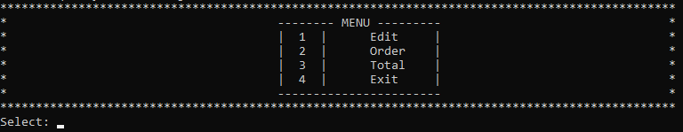

1. **Edit all information**

* You select : 1 “Edit”

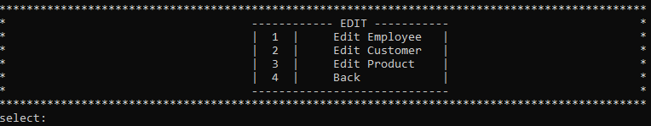

* You want edit Employee - Select : 1

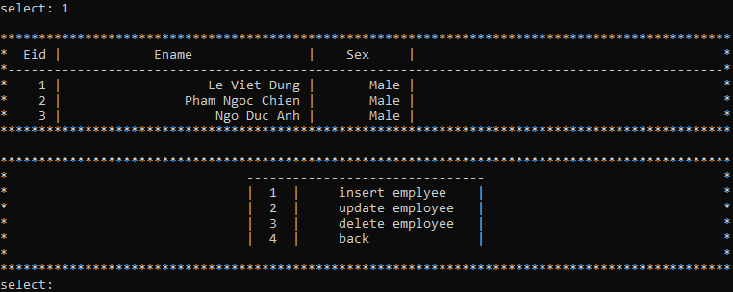

The employee section stores all information of the employee standing order

* You want edit Customer – Select : 2

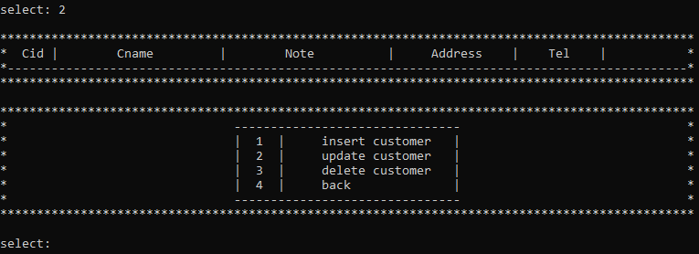

The customer part stories all customer order information remotely to prevent the order employee from leaving the customer’s order

* You want edit Product – Select : 3

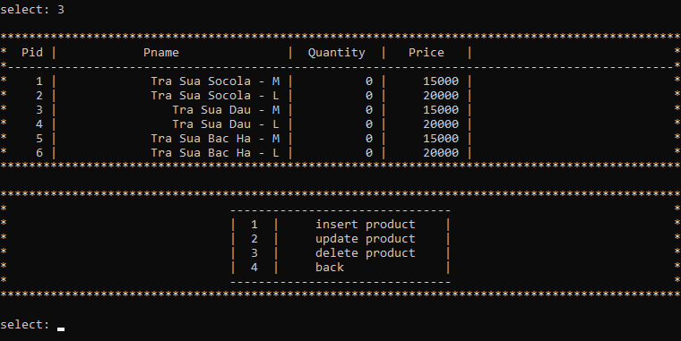

The product section stories the product list, quantity, and price of the shop, which helps employee easily manage inventory and product prices when selling to customers

1. **Order**

* To start order you select : 2

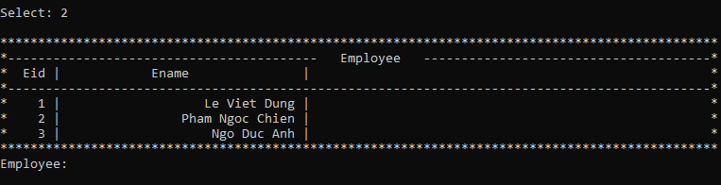

* In the first step , you will select the order’s name instead of having to log in from the beginning
* The next step will fill in customer information (if it’s not necessary to “null” or randomize anything).

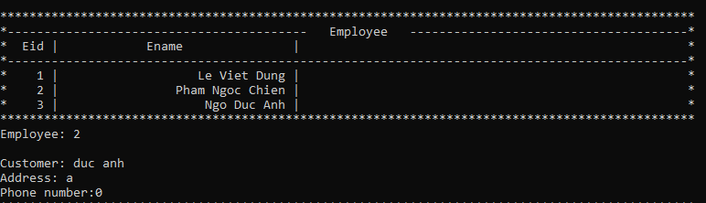

* Next step is order information. Customer will choose the name of drink, quantity, topping

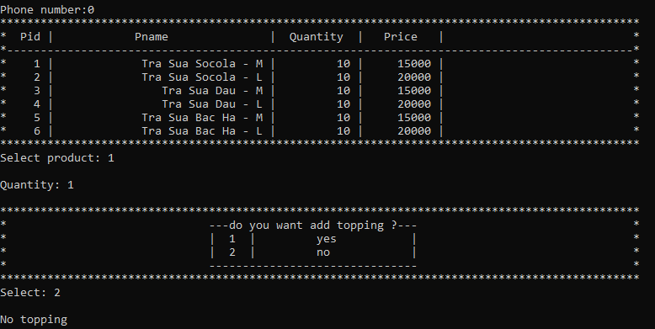

* When completing the order process , the will automatically print invoices for customers.

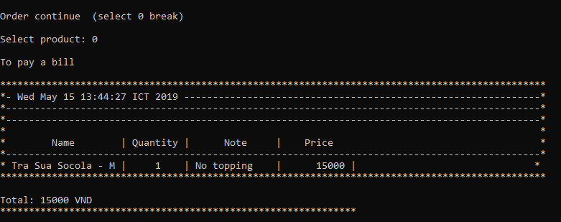

1. **Total**

* Start total you select : 3
* The total will display all invoice information orders in date and price from.

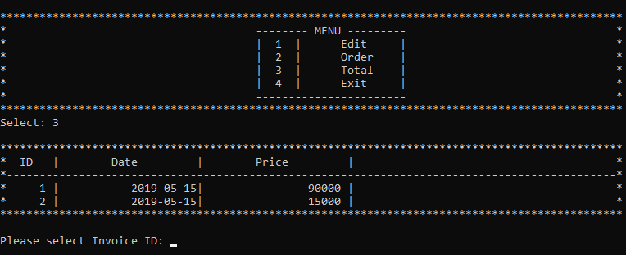

* To view the line item you select the id of that order

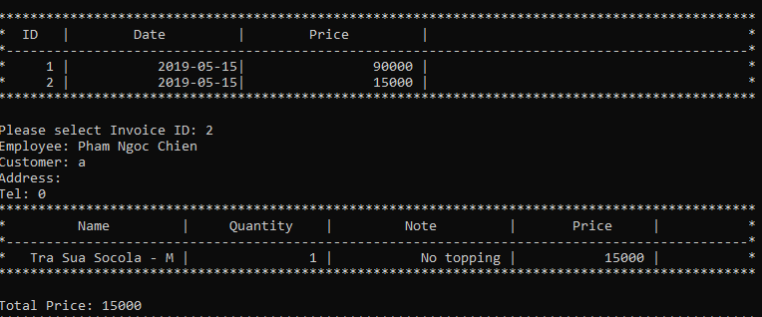

1. **Exit**

* End the time when the employee select exit to exit the application

